**Detection of Corrosion:**

* <https://doi.org/10.1179/1743278215Y.0000000057>

Detection of Corrosion using Electrochemical Noise(EN). This method of testing has been employed for over 50 years in detection of corrosion.

The setup consists of three methods to measure EPN(Electrochemical Potential Nosie) and ECN(Electrochemical Current Noise), The first method is the noiseless reference electrode(RE). that uses two electrodes being used and measuring current fluctuations between them. The next system is a noisy RE, where a voltage measurement is done between the two electrodes that’s connected to the ZRA and a third electrode. Finally an asymmetric system with a noiseless RE.

* **End point detection of welds**

The setup consists of a belt grinder and accelerometer to identify the stages of the weld. The accelerometer signatures and force signatures are collected and parameters are extracted from these signals using the Daubechies-4 wavelet function. The parameters such as mean, variance, SD, waveform etc are extracted and fed to a SVM model for classification

* **Machine Learning for in process end point detection**

The goal of this paper is to define identify the right time to change the tool that is the end point detection in robot assisted polishing. Acoustic sensor, strain and current sensor. The extracted features from these sensors were fed into a ANN to classify the tool status.

* **In Process virtual Verification of weld**

In the above method process(2) the use of accelerometers, force and other signal sensors tend to change in terms of obtained values when the part and type of weld changes. A DSLR Camera is used to collect pictures and then standard augmentation techniques are used to increase the dataset. Sematic segmentation is done to identify the state of the weld and therein the End point detection. This is done by using an Encoder Decoder NN with a VGG 16 architecture for classification.

* **Modelling and monitoring of abrasive**

Abrasive finishing is the process that includes grinding lapping or disc polishing. It is said that with high machining accuracy the material removal rate also increases. Accelerometers and Acoustic Emission sensors are compared. Deep CNN is used for classification of the surface state.

* **Corrosion detection in Industrial pipes using acoustic and Radia Basis Function Neural Network**

Paper focuses on corrosion detection and classification. Internal corrosion detection can be done through ultrasonic, acoustic emission, guided waves, eddy currents, radiographic testing etc. In this setup acoustic waves of different frequencies are passed through one end of the tube and is received via a sensor at the other end. The signals are then processed and parameters such as Rms Mean Kurt, Skew, var are calculated and then passed to an ANN model.

* **Corrosion detection using fiber optic photoacoustic ultrasound generator**

In this paper corrosion is detected on steel reinforces rebar. The ultrasonic generator is based on the photoacoustic principle, it involves three steps energy absorption, thermal expansion and acoustic generation. The ultrasound generator and a hydrophone were placed perpendicular to each other near the sample while being immersed under water.

* **Corrosion detection in aircraft by X ray backscatter methods**

Non-destructive inspection(NDI) is done using X ray backscatter on Aircraft components to detect hidden corrosions. X rays are projected on the surface through a collimator, the backscatter is saved as a response matrix R and this is compared against a standard matrix S. based on the set threshold value the corrosion is identified.

* **Ultrasonic Detection and measurement of Isolated or Pitting Corrosion(IPC)**

The paper focuses on improving the corrosion detection abilities of ultrasonic sensors for pitting corrosion. Use of higher frequencies increase sensitivity and resolution this helps in the measurement process. AS ultrasound is not independently potent to detect general corrosion different configurations of the sensors, wave patterns and parameter settings must be considerd

* **Detection of Inner corrosion of steel construction using Magnetic resistance**

Eddy current testing ECT is a convenient method because it uses a compact and no restrictions on use . A magnetic measurement unit is used to detect the plate thickness using an anisotropic magnetic resistance AMR . It consists of an induction coil , an AMR sensor , a small cancellation coil , a lock in amplifier and a current source.

**Research done on AI based Maintenance**

* For computing the discriminative features, we evaluate and compare a set of techniques including deep neural network, local descriptors, and texture features. As we will show in the results, using CNN as feature extractor achieves the best performance. Therefore, we have used a convolutional neural network (CNN) pre-trained on ImageNet as a feature extractor for our dataset. Transferring the knowledge of an existing CNN to a new domain has been studied and proved successful in several applications (**AIRCRAFT FUSELAGE DEFECT DETECTION USING DEEP NEURAL NETWORKS**)
* The second approach was based on artificial intelligence, in particular using Deep Learning methods. First of all, it allows the reuse of previously trained networks, saving a lot of time. Furthermore, since the “*bvlc_reference_caffenet*” has been already pre-trained with 1 Million images, the network has prior “knowledge” of the correct weight parameters for the initial layers. We could thus reuse that information and avoid over-fitting

problems (excessively complex model and not enough data to constrain it). .(**Corrosion detection using AI: Computer Vison and Deep Learning**)

* Recently, the classification capabilities of computers have increased due to the use of convolutional neural networks (CNNs).5 Currently, CNNs have been demonstrated to achieve human-level classification accuracy on the ImageNet challenge. The main contribution of this work is to present a CNN and sliding window approach for corrosion detection that outperforms the existing state-of-the-art corrosion detection algorithm. To this end, two existing networks that have shown significant success on ImageNet,30 VGG16 39 and ZF Net,38 are used. (**Evaluation of deep Learning approaches based on cnn for corrosion detection**)
* In this approach we will design and implement a method to detect the corrosion within the metals, the new method will define texture analysis as the main method for this approach, texture analysis normally implement to segment a special objects, however texture analysis can not stand alone without enhancing the images, whereby, the object will be easy to detect. (**Towards Corrosion detection System**)

**Cameras to be used**

The idea interface for cameras on the nano must be one of the two

* MIPI CSI 2(MIPI Camera Serial Interface)
* V4L2

Web cames are mainly supported through the V4L2 interface and other cameras like the Raspberry Pi Camera Module are supported through the MIPI interface.

**Available cameras**

* IDS Mono
* IDS color
* Raspberry pi camera module 2
* Rasp Cam HQ (12 Mp, 7.9mm diagonal, IMX477 sensor) (hardware modifications necessary for nano compatibility)
* ArduCam
  + ArduCam Mini IMX477 HQ(12 Mp, 4056 * 3050, Optical format: 1 / 2.3 inches (diagonal 7.857 mm))
  + ArduCam IMX477 HQ (C adapter)

Questions to be answered

* Since the lens is close to the surface can grinding be done with the lens still close by
* Do we need 2 cameras at different distances to detect the corrosion. One to make the initial detection and provide the coordinate and the next to detect corrosion from a closer range





Data augmentation:

Improving the generalization

ability of these models is one of the most difficult challenges. Generalizability refers

to the performance difference of a model when evaluated on previously seen data (training

data) versus data it has never seen before (testing data). Models with poor generalizability

have overfitted the training data. One way to discover overfitting is to plot the

training and validation accuracy at each epoch during training. The graph below depicts

what overfitting might look like when visualizing these accuracies over training epochs.

Data Augmentation, the focus of this survey, is not the only technique that has been

developed to reduce overfitting.

These augmentations artificially inflate the training dataset size by

either data warping or oversampling. Data warping augmentations transform existing

images such that their label is preserved. This encompasses augmentations such as

geometric and color transformations, random erasing, adversarial training, and neural

style transfer. Oversampling augmentations create synthetic instances and add them to

the training set. This includes mixing images, feature space augmentations, and generative

adversarial networks (GANs).

It is a generally accepted notion that bigger datasets result in better Deep Learning

models [23, 24].

Various works on GAN extensions

such as DCGANs, CycleGANs and Progressively-Growing GANs [34] were published

in 2015, 2017, and 2017, respectively.

The use of GANs in medical imaging is well documented in a survey by Yi et al.

[39]. This survey covers the use of GANs in reconstruction such as CT denoising [40],

accelerated magnetic resonance imaging [41], PET denoising [42], and the application

of super-resolution GANs in retinal vasculature segmentation [43]. Additionally,

Yi et al. [39] cover the use of GAN image synthesis in medical imaging applications

such as brain MRI synthesis [44, 45], lung cancer diagnosis [46], high-resolution skin

lesion synthesis [47], and chest x-ray abnormality classification [48]. GAN-based

image synthesis Data Augmentation was used by Frid-Adar et al. [49] in 2018 for liver

lesion classification.

**Camera Parameters Set:**

Resolution: Full res | 1280 x 960 | 1920 x 1080(Full HD) |

FPS : 19 | 37.94 | 34 |

AI

ML

DL

a

Output

Hidden

Input

y

y

a

a

a

x

x

x

**IOU =**

Hardware Selection

Training the model

Building the model

Data Preparation

Model Development

Data Annotation

Synthetic Data Generation

Data Collection

Testing

Deployment

|  |  |  |  |  |  |  |  |  |  |
| --- | --- | --- | --- | --- | --- | --- | --- | --- | --- |
| Model | Res | TP | FP | FN | AP | Precesion | Recall | F1 score | Conf-thres |
| YOLOv4 Tiny | 416 | 245 | 127 | 98 | 70.29% | 0.66 | 0.71 | 0.69 | 0.25 |
| YOLOv4 | 416 | 200 | 80 | 143 | 58.26 | 0.71 | 0.58 | 0.64 | 0.25 |
| YOLOv4 Tiny | 640 | 240 | 114 | 103 | 71.81% | 0.68 | 0.70 | 0.69 | 0.25 |
| YOLOv4 Tiny | 960 | 234 | 147 | 109 | 69.21 | 0.61 | 0.68 | 0.65 | 0.25 |
| YOLOv4 | 640 | 207 | 104 | 136 | 55.69 | 0.67 | 0.60 | 0.63 | 0.25 |
| YOLOv4 small | 416 | 177 | 75 | 166 | 52.49 | 0.70 | 0.52 | 0.51 | 0.25 |

Detection Model Results:

Training Set:800

Valid Set:50

|  |  |  |  |  |  |  |  |  |  |
| --- | --- | --- | --- | --- | --- | --- | --- | --- | --- |
| Model | Res | TP | FP | FN | AP | Precesion | Recall | F1 score | Conf-thres |
| YOLOv4 Tiny | 416 | 245 | 127 | 98 | 70.29% | 0.66 | 0.71 | 0.69 | 0.25 |
| YOLOv4 | 416 | 200 | 80 | 143 | 58.26 | 0.71 | 0.58 | 0.64 | 0.25 |
| YOLOv4 Tiny | 640 | 240 | 114 | 103 | 71.81% | 0.68 | 0.70 | 0.69 | 0.25 |
| YOLOv4 Tiny | 960 | 234 | 147 | 109 | 69.21 | 0.61 | 0.68 | 0.65 | 0.25 |
| YOLOv4 | 640 | 207 | 104 | 136 | 55.69 | 0.67 | 0.60 | 0.63 | 0.25 |
| YOLOv4 small | 416 | 177 | 75 | 166 | 52.49 | 0.70 | 0.52 | 0.51 | 0.25 |

|  |  |  |  |  |  |  |  |  |  |
| --- | --- | --- | --- | --- | --- | --- | --- | --- | --- |
| Model | Res | TP | FP | FN | AP | Precesion | Recall | F1 score | Conf-thres |
| YOLOv4 Tiny | 416 | 245 | 127 | 98 | 70.29% | 0.66 | 0.71 | 0.69 | 0.25 |
| YOLOv4 | 416 | 200 | 80 | 143 | 58.26 | 0.71 | 0.58 | 0.64 | 0.25 |
| YOLOv4 Tiny | 640 | 240 | 114 | 103 | 71.81% | 0.68 | 0.70 | 0.69 | 0.25 |
| YOLOv4 Tiny | 960 | 234 | 147 | 109 | 69.21 | 0.61 | 0.68 | 0.65 | 0.25 |
| YOLOv4 | 640 | 207 | 104 | 136 | 55.69 | 0.67 | 0.60 | 0.63 | 0.25 |
| YOLOv4 small | 416 | 177 | 75 | 166 | 52.49 | 0.70 | 0.52 | 0.51 | 0.25 |

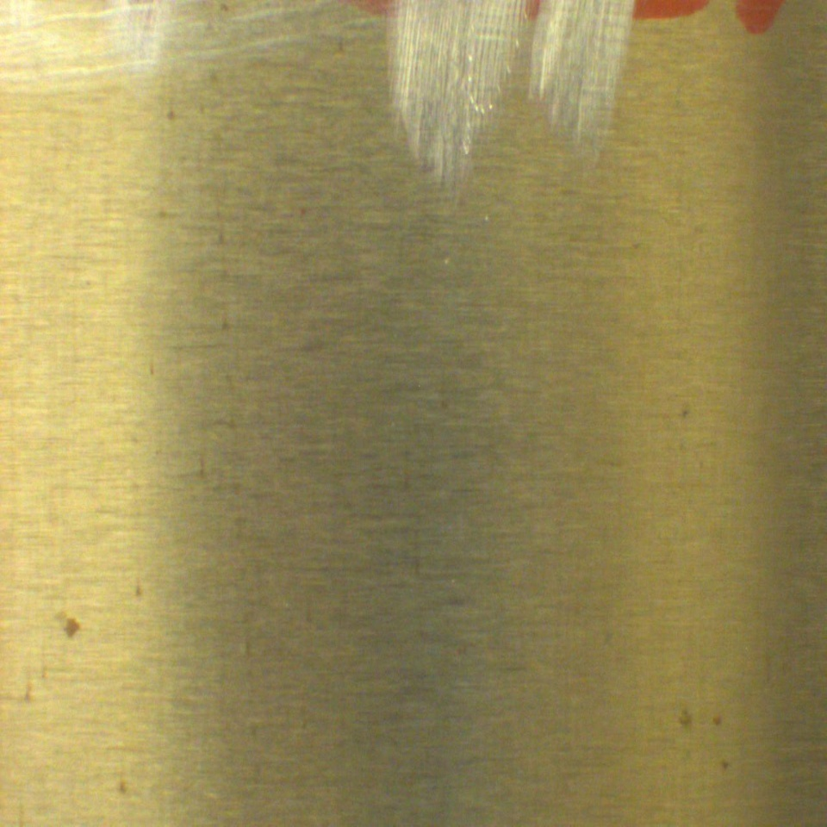

|  |  |  |  |  |  |  |  |  |  |
| --- | --- | --- | --- | --- | --- | --- | --- | --- | --- |
| Model | Res | TP | FP | FN | AP | Precesion | Recall | F1 score | Conf-thres |
| YOLOv4 Tiny | 416 | 191 | 122 | 82 | 69.68 | 0.61 | 0.70 | 0.65 | 0.25 |
| YOLOv4 | 416 | 181 | 79 | 92 | 66.37 | 0.70 | 0.66 | 0.68 | 0.25 |
| YOLOv4 Tiny | 640 | 187 | 121 | 86 | 66.08 | 0.61 | 0.68 | 0.64 | 0.25 |
| YOLOv4 Tiny | 960 | 190 | 146 | 83 | 63.7 | 0.57 | 0.70 | 0.62 | 0.25 |
| YOLOv4 | 640 |  |  |  |  |  |  |  | 0.25 |
| YOLOv4 small | 416 |  |  |  |  |  |  |  | 0.25 |
| YOLOv4 anchor | 416 | 180 | 75 | 93 | 66.04 | 0.71 | 0.66 | 0.68 | 0.25 |
| YOLOv4 tiny rand1 | 416 | 193 | 127 | 80 | 6.61 | 0.60 | 0.71 | 0.65 | 0.25 |

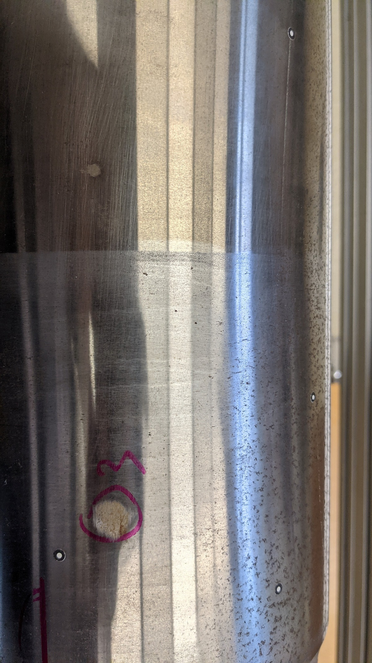

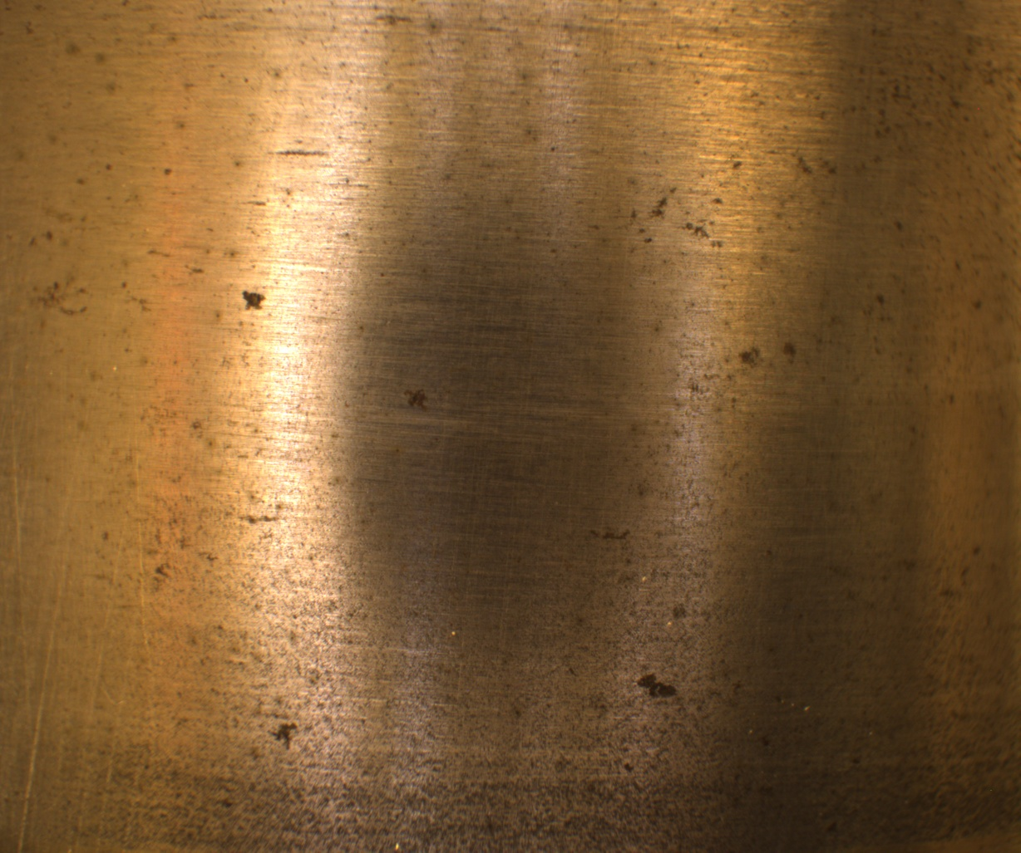

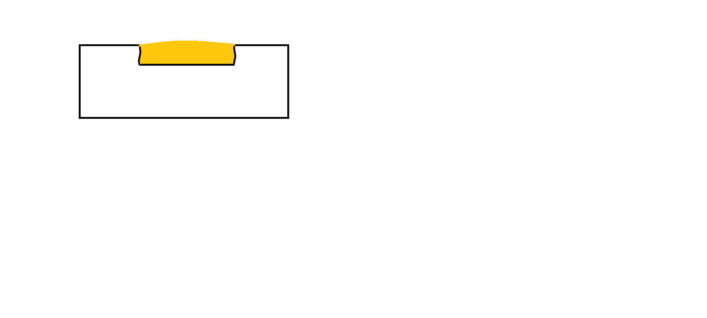

**Corrosion**

**Endpoint**

|  |  |  |  |  |  |  |  |  |  |
| --- | --- | --- | --- | --- | --- | --- | --- | --- | --- |
| Model | Res | TP | FP | FN | AP | Precesion | Recall | F1 score | Conf-thres |
| YOLOv4 Tiny | 416 | 81 | 27 | 23 | 83.61 | 0.75 | 0.78 | 0.76 | 0.25 |
| YOLOv4 | 416 | 74 | 17 | 30 | 74.04 | 0.81 | 0.71 | 0.76 | 0.25 |
| YOLOv4 Tiny | 640 | 82 | 33 | 22 | 85.12 | 0.71 | 0.79 | 0.79 | 0.25 |
| YOLOv4 Tiny | 960 |  |  |  |  |  |  |  | 0.25 |
| YOLOv4 | 640 | 73 | 27 | 31 | 72.82 | 0.73 | 0.70 | 0.72 | 0.25 |
| YOLOv4 small | 416 |  |  |  |  |  |  |  | 0.25 |
| YOLOv4 anchor | 416 |  |  |  |  |  |  |  | 0.25 |
| YOLOv4 tiny rand1 | 416 |  |  |  |  |  |  |  | 0.25 |

Lufthansa NDT method

1. regarding the tools used: during the visit we saw

Straight grinders (in different lengths).

Which grinding attachments (dimensions, grit) and parameters,

(speeds, coarse contact pressure) do the workers use for machining?

I have been able to identify 2 high-speed grinders that are used in the findings.

with the following data:

(a) BIAX SARD 820, max. 300 watts power, max. 17,000 rpm.

No-load speed

b) MINIFIX 9-R, max. 500 watts of power, max. 9000 rpm

Idling speed

The abrasive used is an abrasive roll with min. 20mm to

max. 30mm abrasive roll diameter and 50 to 320 grit aluminium

oxide. The contact pressure is as low as possible in order to remove as little material as possible.

Are the tools and attachments approved by aviation law or do they have to be approved?

do they have to be approved?

The OEM publishes a document called "Standard Practices

Documents" in which relevant processes of chrome plating, heat treatment, NDT, etc. are explained.

etc. are explained. There is partly a framework given in which a tool should

a tool should move. Before procurement, this is of course

checked. If there is a deviation from this framework, we have to have it

have to have this approved via separate processes. As far as I know

attachments, etc., are not tested for aviation regulations and subsequent

subsequent steps (NDT, heat treatment) to ensure that no damage to the

damage has occurred to the component.

2 (Manual) Machining Strategy

The machining strategy is presumably oriented to the CMM. Are

similar to the FAA's Advisory Circular 43-4B, for example (cf.

(cf. Appendix, Section 6.15)?

Correctly in the CMM, machining strategies are defined for components.

It explains, for example, which machining steps must be carried out if a

if corrosion is found in the bore of a track fork.

That is, to which dimension may the bore be milled, which NDT process must be carried out, heat treatment, etc.?

processes must be carried out, heat treatment, etc. Now of course it can

corrosion occurs locally at a point for which no machining is described in the

machining is described in the CMM. In this case we can partly

parts with the "general repair limits" of the CMM (see appendix

1). However, especially in the case of runtime-limited components, the

OEM (in this case SAFRAN) must be contacted to get an approval in the form of a concession.

in the form of a concession. To give you a feeling of what these

what these instructions from the OEM look like, I have uploaded (incomplete)

repair instructions in the attachment.

Appendix 2 is a sliding tube made of 300M steel and manual blends.

blends in the axle. Appendix 3 is the

repair instructions for an aluminium strut.







